AfterScan
Description of the UI elements, and basic functionality
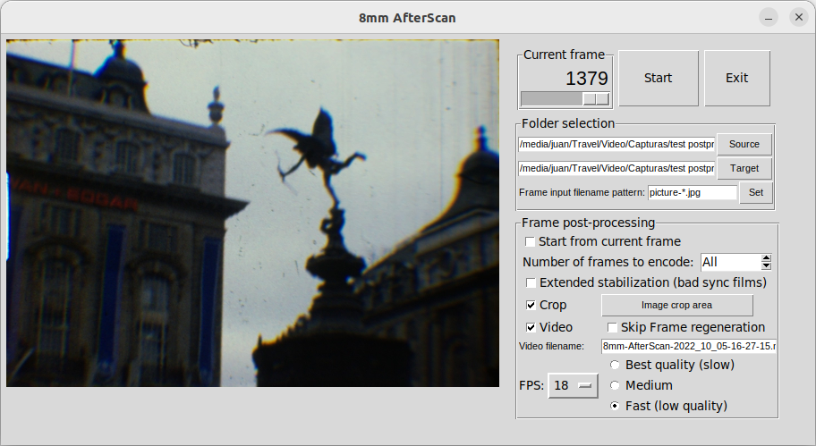

- Start button: Start/Stop frame processing
- Exit button: Terminates application
- Current Frame: Displays frame being processed. Slider allow to manually select a specific frame in case processing should not start from first frame (selection can be done with the keyboard, just use the mouse to set the focus on the slider)
- Folder selection: Allows to select source folder (where frames from scanner are stored) and target folder (where new stabilized and cropped frames, and video if selected, will be stored) Folders need to be different since frame files might have the same name.
- Frame input filename pattern: Specify the patter AfterScan will use to fetch the files with the film frames generated by the scanner.
- Frame post-processing:
  - Start from current frame: By default, AfterScan starts processing with the first frame (lowest sequential number). If this option is selected it will start with the frame displayed in the ’Current Frame’ box (see above)
  - Number of frames to encode: By default, AfterScan processes all frames present in the source folder. With this option (along with the previous one) a subset can be selected to perform partial processing.
  - Extended stabilization (bad sync films): In order to perform the stabilization task AfterScan searches for the sprocket hole in the area where it is normally expected to be (middle of left side of the frame). Sometimes, specially with old films, the scanner cannot position the frame correctly during the capture, resulting in a frame snapshot where the sprocket hole appears quite out of the usual area (too high, too low). Selecting this option tells AfterScan to extend the area where is searches for the hole, better dealing with such cases. A couple of remarks:
    - Due to the extended search, the total process duration will be longer when this option is selected
    - In these cases also, some degradation in the stabilization is to be expected. When the hole is too out of place, part of the original frame will not appear in the capture, so AfterScan will not be able to produce a perfectly centered frame
  - Crop: Before this option can be selected a crop area must be defined by using the ‘Image crop area’ button to the right. This allows to select the region of the original frame that will be included in the frame produced by AfterScan, so that unwanted parts of the film (sprocket hole, dirt in the borders) can be removed in the target.
  - Video: When selected, AfterScan will generate a video once all the frames have been processed.
    - Please note that video is generated by means fo FFmpeg, that should have been previously installed in the system, and accessible by AfterScan via the system path.
  - Skip frame regeneration: Just what it says, if frames were already generated in a previous session, selecting this option will ump directly to the video generation part.
  - Filename: A name for the video file can be stated here. If left empty, AfterScan will generate one, with a timestamp on it.
  - FPS: Specifies the frames per second of the original film (18 FPS usually for Super 8)
  - Video generation quality: Allows to decide whether we want to have the best quality, or a fast processing. By default, medium is selected.
    - Important note. Progress of video generation is reported only in the console, as reported by FFmpeg. This reporting will be moved to a popup in the UI when a clean solution is found to do it.
  - Stabilize details: This section is only displayed when expert mode (‘-e’) is selected. It contains elements to allow further customization of the elements used during the sprocket hole search:
    - Pattern: This is the image that is used to match the sprocket hole. It is better to use only a fragment of the right part of the hole, since films that have been scanned with a strong zoom (to maximize the captured image area) might not have the full hole, just a fragment.
    - Sprocket hole search area: This allow to personalize the area where the AfterScan will search for the sprocket hole. Normally, with the ‘Extended stabilization’ option in the standard UI should be enough, but for special cases this option can be used.
      - Remember that the search area should be as reduced as possible not only to optimize the hole search time, but also to reduce false positives (which sill happen if the full frame I selected)

